

Operation Newstart
50 Flemington St
Travancore
VICTORIA 3032

Operation Newstart Victoria and (Inc)
Annual Report 2025

As we enter our thirtieth year, I have had the opportunity to reflect on the objectives of Operation Newstart as outlined by our foundation team back in 1997. John Burrell, principal at Mt Erin Secondary College, and our first chairperson wrote on completion of our first twelve months: “Operation Newstart is a successful program that assists young people to get back on track. By building confidence, self-esteem, coupled with the development of personal skills and the gaining of significant qualifications, allowing graduates longer term positive outcomes.” He also wrote this of Newstart participants: “They do not fall into the low academic achiever’s category that many label those young people who fail to make it in the school environment. In fact, many of our participants have proven to be gifted.” As guiding principles, these remain as true today as they were then.

Paul Kill, the foundation program facilitator at Operation Newstart Frankston, pointed out after the completion of his first year that Operation Newstart is the only program of its kind in Victoria. We can confidently say thirty years on that this remains the case.

I am providing below the data for all programs in 2025. Our total number of participants has decreased as a consequence of the loss of Operation Newstart Geelong this year, a loss that is keenly felt among most of last year’s participating schools in the Greater Geelong region.

Program | Total Intake | Male | Female | Gender Diverse | CALD | First Nations | LGBTQI+ | Neurodiverse
ONC | 36 | 18 | 18 | - | 6 | 1 | - | 9
ONN | 29 | 14 | 15 | - | 3 | 1 | - | 17
ONSE | 25 | 15 | 10 | - | 13 | 0 | - | 5
ONW | 36 | 18 | 18 | - | 13 | 1 | - | 10
Total | 126 | 65 | 61 | - | 35 | 3 | - | 41
Percent | 100% | 52% | 48% | 0 | 28% | 2% | 0 | 33%

Mental health data from Operation Newstart Southeastern: 2022-2026.

Operation Newstart Southeastern has now collected mental health data on all participants attending from intakes 69 to 83 inclusive (T=99). 31% were treated by a medical practitioner for symptoms of severe trauma, anxiety, depression, suicide ideation. 55% (T=17) of this group were medicated (chiefly ADHD) at the time of entry. A third group titled: “Possible mental illness, not diagnosed but likely and never been assessed” is determined by the facilitation team including school staff after referral into a program. It indicates that a further 39% (T=40) of participants are experiencing some form of mental illness, or at best, emerging mental illness. Similar conditions such as anxiety, depression and trauma are reported to program teams. Frequently the participants will indicate they are waiting to see a doctor. Program leader, Declan Denneny feels that the number of students entering his program with mental health problems has significantly increased since the pandemic years and is represented by a noticeable increase in school refusal reported by teaching staff.

An observation when reviewing the early documents relating to our foundation programs back in 1996 and 1997 is the lack of references to mental ill-health as a significant risk factor in student disengagement. In its place are frequent references to the anti-social behaviour of candidates mainly in the classroom or at school with little attention paid to mental health or neurodiversity and their linkage to that anti-social behaviour.

Partnership with Victoria Police:

Looking back again into our history, Operation Newstart was established equally by Victoria Police and the secondary colleges in each region. It remained a full partnership with police officers staffing programs in equal numbers to schoolteachers until 2013. It is pleasing this year to see a consolidation of our relationship with Victoria Police, in particular the Proactive Policing Units in each of our four programs. Youth Resource Officers have engaged with students each term in all programs. Their focus is naturally to prevent crime before it occurs through community engagement, educating and targeting high-risk groups. In our Western program, police have regularly attended overnight camps and have contributed up to four days each term assisting in program delivery. The consensus among our facilitation teams is that participants respond well, respecting the officers’ positions of authority and gaining insights into their rights and responsibilities. We must remain fully committed to community capacity building through partnering with local government youth services departments and local police among a broader range of local and state-based agencies.

Changes to our organisational structure:

Operation Newstart Incorporated applied successfully to the Australian Taxation Office (ATO) through the Australian Charities and Not-for-Profit Commission (ACNC) for tax concessions. From November 2025, Operation Newstart Inc is now registered as a Public Benevolent Institution and endorsed as a Deductible Gift Recipient with several other tax exemptions. I would like to acknowledge the contribution of James Graham, our solicitor who undertook many hours of work on a pro bono basis and our treasurer, Ray Paul who assisted me in the preparation of documents. I would also like to acknowledge the generous assistance of the staff at ACNC and the ATO for their support and consideration. There have been some minor changes to our Rules of Association which is available for viewing on the ACNC website. Otherwise, all future applications for funding will now be undertaken by Operation Newstart Inc.

Our donors in 2025:

We are once again indebted to the R.E.Ross Foundation for providing the final tranche of $35,000 to assist Operation Newstart Inc in its work with programs. Their assistance over the past three years has resourced Operation Newstart, enabling us to continue advocating for support with participating schools, sponsors and with government agencies.

While Operation Newstart is not funded directly by the Department of Education, its support for our work is evident via the participation of more than sixty state secondary colleges in 2025. Other government funding through the Department of Fairness, Family and Housing ($45,000) and the Department of Justice through Magistrate Court grants paid directly to host schools is vitally important and will continue into the coming year. The Engage Grant continues to support Operation Newstart Northern until the end of semester 1, 2027 with half yearly payments of $22,500.

Our four programs pivot on the continuing contribution of our four host schools: Dandenong High School, Travancore School, Cranbourne East Secondary College and Collingwood College. These schools make a very special contribution to the success of each program. Despite grant money they receive through our efforts, they cover substantial financial shortfalls, offer encouragement and support to program facilitators, provide program housing and generally are Operation Newstart champions. The annual cost of running each program is now close to $250,000 and cost pressures continue to impose extra challenges on schools and on Operation Newstart programs. Special thanks must go to the principals for their encouragement and to the business managers for their regular oversight of costs.

This year we received $57,500 from the Williams family to support vital youth work in Operation Newstart Southeastern. The family will provide a further $30,000 for the same youth work subsidy to Operation Newstart Casey in 2026. Our sincere thanks to Paul and Judy for their annual assistance. Their contributions are making an enormous difference to the success of both programs.

We are also indebted to the Bushell Foundation for granting a further $42,000 to assist in staffing costs for Operation Newstart Casey and Operation Newstart Northern in 2025. The Foundation contributed $85,000 in 2024-25 and we are most appreciative.

Local government grants have also been received from the City of Yarra ($10,000); City of Nillumbik ($5,275); the City of Casey ($5,000); the City of Merri-bek ($10,000). School Focus Youth Service (Healthability) contributed $10,000 to assist Operation Newstart Northern in program delivery. Rotary Clubs have also contributed to Operation Newstart Casey recognising the great work of program manager Jimmy Seeary by awarding him Rotary International’s highest honour – a Paul Harris Fellowship for his nearly 20 years’ service to Casey’s youth.

Our Facilitators in 2025:

Operation Newstart programs are staffed by a wonderful team of professionals committed to the wellbeing of young people. They freely give of their time often outside normal school hours. They meet collegially each term and keep in regular contact with each other to ensure best practice and innovation between programs.

Our program facilitators in 2025 were:

Operation Newstart Western: Paul Stafford, Daniel Beeson.
Operation Newstart Casey: James Seeary, Jessica Bassilios.
Operation Newstart Northern: Brendon Delaney, Laura Roulston.
Operation Newstart Southeastern: Declan Denneny, Shannon Stephens.

Our thanks to Daniel Beeson who leaves Operation Newstart Western at the end of 2025 for a position at Warringa Park school.

I would also like to acknowledge the many trainee youth worker placements in 2025 who play such an important role in staffing of programs.

Our Board of Directors in 2025:

Four ordinary board meetings were held in 2025, and one extraordinary meeting was held to approve a Special Resolution to make changes to our Rules of Association. I am most grateful to all members and special thanks to Dr Pam St Leger for her wonderful chairmanship of our meetings, and for her continuing support. The membership of the board is as follows:

Dr Pamela St Leger (Chairperson)
Phil Wheatley OAM (Executive Director)
Ray Paul (Accountant/Treasurer)
Russell Lee (Principal)
Katie Archibald (Principal)
Mark Dewar (Deputy Principal)
Andrew Simmons (Director, SELLEN)
Paul Stafford (Teacher Facilitator)
Brendon Delaney (Teacher Facilitator)
James Seeary (Teacher Facilitator)
Melanie Singleton (Head of Campus, Collingwood Alternative School)

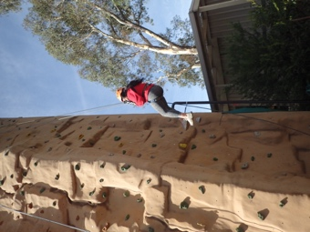 | 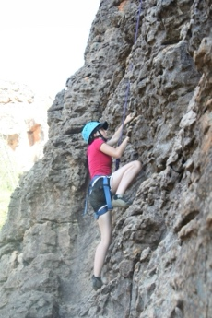 | 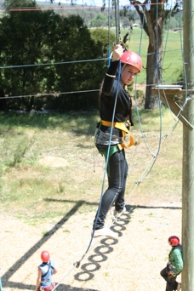 | 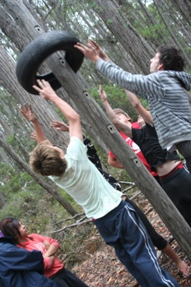 | 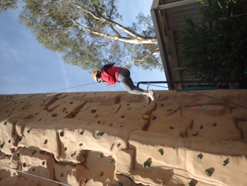

Executive Director: Phil Wheatley………………………………………………………….

Dated: 16th March 2026.

Operation Newstart – Briefing and background paper: A program for youth at educational risk. August 1998.

